# **TASK -> Differences between Document and Window Objects**

**What is a JavaScript window? :**

The window is at a root/top level at the JavaScript object hierarchy. It is a global/root object in JavaScript and it is the root object of the Document object model(DOM).

The first thing that gets loaded into the browser is the window and the properties related to that window are stored in the window object.

Properties related to window objects are length, innerWidth, innerHeight, caches, etc.

**Syntax:**

**window object:**

Window.propertyname;

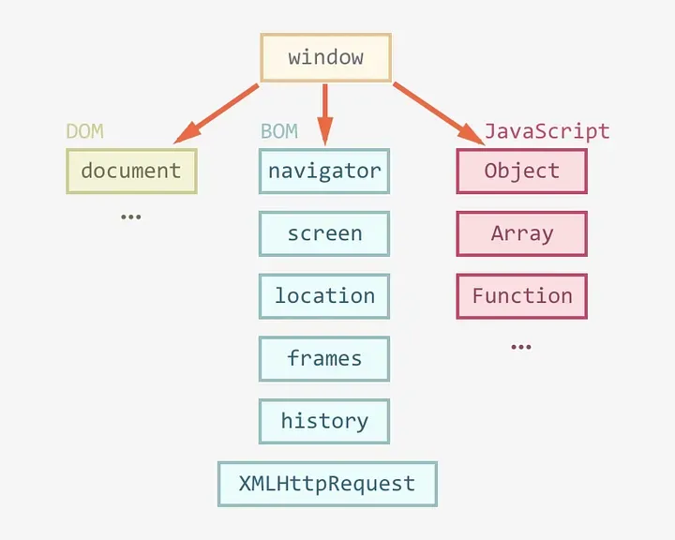

**The methods of Window objects that are commonly used are listed:**

[**alert()**](https://www.geeksforgeeks.org/html-window-alert-method/): It is used to display an alert box. It displays a specified message along with an OK button and is generally used to make sure that the information comes through the user.

[**close()**](https://www.geeksforgeeks.org/javascript-window-close-method/)**:** It is used for closing a certain window or tab of the browser which was previously opened.

[**confirm()**](https://www.geeksforgeeks.org/javascript-window-confirm-method/)**:** It is used to display a modal dialog with an optional message and two buttons i.e. OK and Cancel. It returns true if the user clicks “OK”, and false otherwise.

[**open()**](https://www.geeksforgeeks.org/javascript-window-open-method/): It is used to open a new tab or window with the specified URL and name.

[**setTimeout()**](https://www.geeksforgeeks.org/java-script-settimeout-setinterval-method/): It executes a function, after waiting a specified number of milliseconds.

[**prompt()**](https://www.geeksforgeeks.org/javascript-window-prompt-method/): It is used to display a dialog with an optional message prompting the user to input some text.

**The properties of Window objects that are commonly used are listed:**

**console**: It returns a reference to the console object which provides access to the browser’s debugging console.

[**Document**](https://www.geeksforgeeks.org/html-dom-window-document-property/): It returns a reference to the document object of that window.

**Location**: It contains the URL of the current window.

[**Name**](https://www.geeksforgeeks.org/html-window-name-property/): It contains the name of the referenced window.

**Window**: It returns the current window or frame.

[**Toolbar**](https://www.geeksforgeeks.org/web-window-api-window-toolbar-property/): It will result in the toolbar object, whose visibility can be toggled in the window.

[**Opener**](https://www.geeksforgeeks.org/html-dom-window-opener-properties/): It contains a reference to the window that opened the current window.

**What is a JavaScript document? :**

A document is an object inside the window object and we use a document object for manipulation inside the document.

So after the window gets loaded then there’s a document (HTML, PHP, or another document) loaded inside that window, and the properties related to that document are stored in the document object. Properties related to document objects are title, URL, cookie, etc.

**Syntax:**

**document object:**

document.propertyname

(OR)

Window.document.propertyname

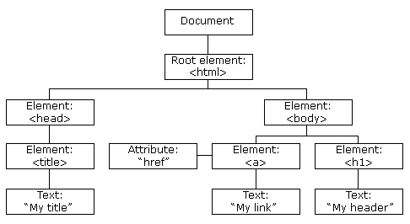

**The lists of most commonly used methods are listed:**

[**close()**](https://www.geeksforgeeks.org/html-dom-close-method/)**:** It is used to close the output stream.

[**createAttribute()**](https://www.geeksforgeeks.org/html-dom-createattribute-method/)**:** It is used to create an attribute node with the specified name and returns the attribute objec**t.**

[**createElement()**](https://www.geeksforgeeks.org/html-dom-createelement-method/)**:** It is used to create HTML elements .

[**createEvent()**](https://www.geeksforgeeks.org/html-dom-createevent-event-method/)**:** It is used to create a new events object.

[**createTextNode()**](https://www.geeksforgeeks.org/html-dom-createtextnode-method/)**:** It is used to create a text node.

[**getElementById()**](https://www.geeksforgeeks.org/html-dom-getelementbyid-method/)**:** It returns the object of the given ID. If no object with that id exists then it returns null.

[**getElementsByClassName()**](https://www.geeksforgeeks.org/html-dom-getelementsbyclassname-method/)**:** It returns an object containing all the elements with the specified class names in the document as objects.

[**getElementsByName()**](https://www.geeksforgeeks.org/html-dom-getelementsbyname-method/)**:** It returns an object containing all the elements with the specified name in the document as object**s.**

[**getElementsByTagName()**](https://www.geeksforgeeks.org/html-dom-getelementsbytagname-method/): It returns an object containing all the elements with the specified tag names in the document as objects.

[**renameNode()**](https://www.geeksforgeeks.org/html-dom-renamenode-method/)**:** It is used to rename the node.

**The properties of document objects that are commonly used are listed:**

[**body**](https://www.geeksforgeeks.org/html-dom-body-property/)**:** It returns the contents of the body element.

[**baseURI**](https://www.geeksforgeeks.org/html-dom-baseuri-property/)**:** It returns a string value that represents the base URI of the documen

[**URL**](https://www.geeksforgeeks.org/html-dom-url-property/)**:** It returns the complete URL of the document.

[**title**](https://www.geeksforgeeks.org/html-dom-title-property/)**:** It returns the title element of the document.

[**head**](https://www.geeksforgeeks.org/html-dom-head-property/)**:** It returns the head element of the document.

| **Document** | **Window** |
| --- | --- |
| It represents any HTML document or web page that is loaded in the browser. | It represents a browser window or frame that displays the contents of the webpage. |
| It is loaded inside the window. | It is the very first object that is loaded in the browser. |
| It is the object of window property. | It is the object of the browser. |
| All the tags, elements with attributes in HTML are part of the document. | Global objects, functions, and variables of JavaScript are members of the window object. |
| We can access the document from a window using the window. document | We can access the window from the window only. i.e. window.window |
| The document is part of BOM (browser object model) and dom (Document object model) | The window is part of BOM, not DOM. |
| Properties of document objects such as title, body, cookies, etc can also be accessed by a window like this window. document.title | Properties of the window object cannot be accessed by the document object. |
| syntax:  document.propertyname; | syntax:  window.propertyname; |
| example:  document.title : will return the title of the document | example:  window.innerHeight : will return the height of the content area of the browser |